**Creating the table and loading the data**

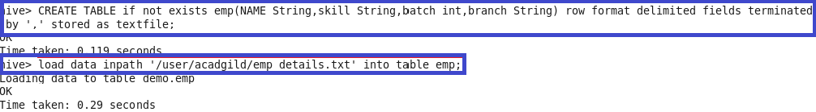

**Problem Statement:**

**Calculate the number of employees corresponding to each skill from the table 'employee' which is loaded in the Demo.**

